|  |  |  |  |
| --- | --- | --- | --- |
| 2 | | 59,664.0 | |
| NUMERO DE FRONTERAS | | ENERGIA AGREGADA | |
|  | | | |
| SI | | 31-12-2020 | |
| CONTRATO | | VENCIMIENTO CONTRATO | |
|  | | | |
| 225,638,853 | 129 | | 9,183,316 |
| INGRESO 2020 | DÍAS CERTIFICADOS 2020 | | ENERGIA RESPALDADA 2020 |
|  | | | |
| 36,992,581 | 23 | | 1,646,976 |
| INGRESO 2021 | DÍAS CERTIFICADOS 2021 | | ENERGIA RESPALDADA 2021 |

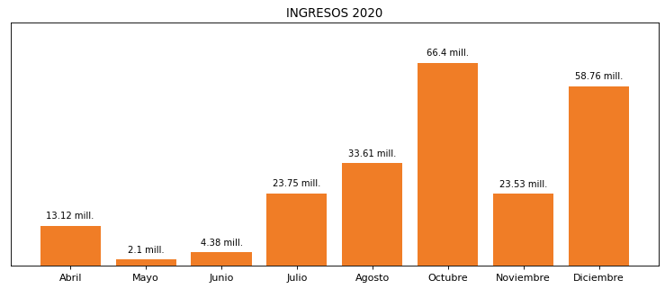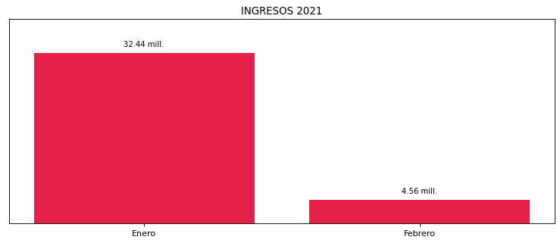

|  |
| --- |
| **VIDRIO ANDINO**  USUARIO |

|  |
| --- |
| **Juan Marin**  Ejecutivo de cuenta |

|  |
| --- |
| **Diego Moya / 0 / Diego.Moya@saint-gobain.com**  Primera fecha: PUNTO FOCAL |

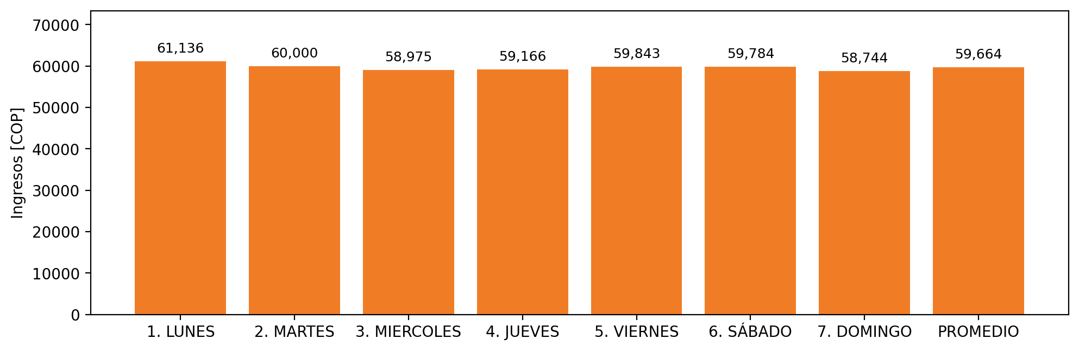

|  |  |  |  |  |  |  |  |  |  |
| --- | --- | --- | --- | --- | --- | --- | --- | --- | --- |
| **FRONTERA COMERCIAL** | **TIPO DDV** | **COD SIC** | **PREDIO** | **PROMEDIO** | **MARGEN** | **ÚLTIMA DESCONEXION** | **DÍAS CERTIFICADOS** | **ACTUALIZACION** | **PROXIMA PRUEBA DDV** |
| VIDRIO ANDINO S.A | Frt36478 | Frt19786 | Prd01603 | 59,664 | 4,29 | 2020-09-17 | 87.0 | 2021-11-23 | 2021-11-30 |
| VIDRIO ANDINO S.A | Frt36479 | Frt19785 | Prd01604 | 59,664 | 3,67 | 2020-11-09 | 67.0 | 2021-11-23 | 2021-12-28 |